

**YEAR: 11**

**SUBJECT: ATAR HUMAN BIOLOGY UNITS 1 AND 2**

**TEST: Foetal Development, Diagnosis of Foetal Health, Birth, Post Pregnancy Changes and Lactation.**

**TIME: 60 minutes**

**QUESTIONS: 20 Multiple Choice (20 marks)**

**9 Short Answers (37 marks)**

**TOTAL MARKS: 57 marks**

**DO NOT WRITE ON OR MARK THIS PAPER**

**MULTIPLE CHOICE SECTION [20 MARKS]**

**Questions 1-20**

1. The ductus venosus diverts foetal blood away from the
   1. lungs
   2. liver
   3. placenta
   4. left ventricle
2. The foramen ovale:
   1. diverts blood from the right atrium to the left atrium
   2. allows blood to flow more freely to the foetal lungs
   3. diverts blood from the left atrium to the right atrium
   4. allows deoxygenated blood in the right atrium to mix with oxygenated blood in the left atrium
3. During birth, the cervix will be fully dilated by the:
   1. end of the first stage of labour
   2. middle of the second stage of labour
   3. end of the third stage of labour
   4. middle of the first stage of labour

4. The vernix is

a. a waxy protective layer that covers the baby at birth.

b. another name for the afterbirth.

c. what remains attached to the umbilicus after the cord has been cut.

d. the removal of the placenta after the baby has been born.

5. A developing foetus has a hole in the heart to allow deoxygenated and oxygenated blood to mix. It is known as the foramen ovale and should close over after birth. With reference to the diagram below, when present, the foramen ovale connects:



a. 9 and 10

b. 4 and 5

c. 1 and 2

d. 2 and 9

6. During child birth there are a number of key events:

i. dilation of the cervix

ii. breaking of the waters.

iii. secretion of oxytocin by the posterior pituitary gland

iv. delivery of the baby

v. crowning

vi contractions of the uterus

vii. delivery of the placenta.

From the list above, the usual sequence of events is:

a. ii, iii, i, vi, v, iv, vii

b. iii, vi, i, ii, v, iv, vii

c. vi, i, iii, ii, iv, v, vii

d. iii, 1, vi, ii, v, iv, vii

7. A child who is breast fed receives

a. antibodies that protect it for life.

b. antibodies that protect it for the first few months of life.

c. antigens that protect it for life.

d. antigens that protect it for the first few months of life.

8. Which of the following is NOT obtained by the foetus from the placenta?

a. Oxygen.

b. Red blood cells

c. Glucose

d. Antibodies.

9. The third stage of labour involves the expulsion of the

a. foetus

b. placenta

c. placenta and membranes

d. placenta, membranes and remains of the umbilical cord.

10. The gestation period of human beings is

a. 365 days

b. 220 days

c. 280 days

d. 150 days.

11. A foetus is

a. an old embryo

b. a newborn baby

c. an unborn baby

d. a fertilized egg.

12. When is the developing embryo/foetus most susceptible to genetic birth defects from exposure to maternal alcohol levels?

a. First trimester

b. Second trimester

c. Third trimester

d. At birth

13. Ultrasound scans have become a common and necessary part of monitoring a pregnancy. While simple and non-invasive, they have several limitations. One limitation is that ultrasound cannot determine:

a. the position of the placenta in the uterus.

b. the risk of many genetically inherited diseases.

c. the sex of the foetus.

d. if the heart is beating

14. Which of the following is NOT a potential outcome for the foetus, of smoking whilst pregnant?

a. Increased growth rate.  
 b. Increased risk of SIDS.

c. Reduced birth weight.

d. Increased chance of respiratory disease

15. The main differences between colostrum and human milk is that colostrum has:-

a. Yellow-white milk which has a lower percentage of fat

b. Fat and a low percentage of water

c. More vitamin C

d. A high fat content to supply the baby with energy straight after birth

16. The volume of milk produced by a lactating mother is controlled by the:

a. amount of Vitamin D in the blood.

b. length and frequency of suckling by the baby

c. size of the pituitary

d. size of the breasts

17. New born infants have difficulty maintaining all the following functions **except**

maintaining.

a. body temperature

b. water balance

c. oxygen requirements

d. metabolic rate

18. Women undergo many changes during pregnancy. Which one of the following is

NOT one of those changes?

a. Enlarged breasts.

b. Increase in blood volume.

c. Increased frequency of passing urine.

d. Increased activity in the digestive system.

19. Parturition is the

a. development of the placenta.

b. process of birth.

c. supply of milk

d. development of the foetus.

20. The hormone responsible for the milk letdown and uterine contractions during

labour is

a. progesterone

b. oestrogen

c. oxytocin

d. prolactin.

.



**TEST 2 Reproduction**

**ANSWER BOOKLET**

**NAME: ______________________________**

Multiple Choice Short Answer Total

**/ 57**

**/ 37**

**/20**

**SECTION ONE:** Multiple choice answers

Cross (X) through the correct answer.

|  |  |  |  |  |  |  |  |  |  |  |
| --- | --- | --- | --- | --- | --- | --- | --- | --- | --- | --- |
| **1** | a | b | c | d |  | **11** | a | b | c | d |
| **2** | a | b | c | d |  | **12** | a | b | c | d |
| **3** | a | b | c | d |  | **13** | a | b | c | d |
| **4** | a | b | c | d |  | **14** | a | b | c | d |
| **5** | a | b | c | d |  | **15** | a | b | c | d |
| **6** | a | b | c | d |  | **16** | a | b | c | d |
| **7** | a | b | c | d |  | **17** | a | b | c | d |
| **8** | a | b | c | d |  | **18** | a | b | c | d |
| **9** | a | b | c | d |  | **19** | a | b | c | d |
| **10** | a | b | c | d |  | **20** | a | b | c | d |

**SHORT ANSWER SECTION**

**___________________________________________________________________**

**1.** Explain what happens in each stage of birth in the table below. (6 marks)

|  |  |
| --- | --- |
| Stage 1 |  |
| Stage 2 |  |
| Stage 3 |  |

**2.** Briefly explain two physical changes to a mother after childbirth (2 marks)

___________________________________________________________________

___________________________________________________________________

___________________________________________________________________

___________________________________________________________________

**3**. Babies born at 25 weeks have a very small chance of survival. State **one** main problem that affects the survival of premature babies. (1 mark)

_______________________________________________________________________

_______________________________________________________________________

_______________________________________________________________________

_______________________________________________________________________

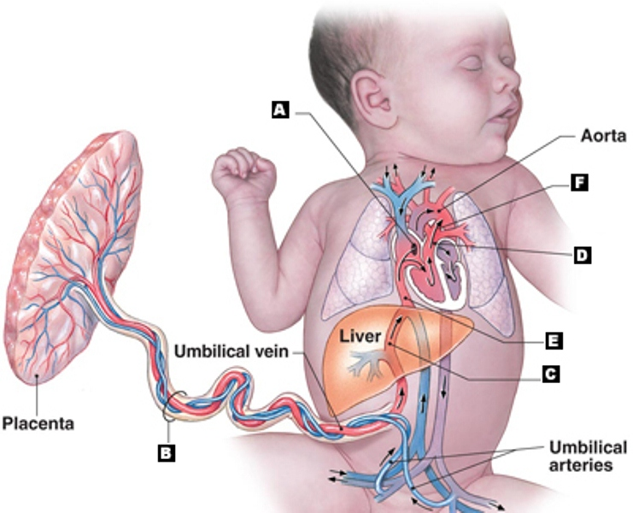

**4.**

a. Using the LETTERS shown in the above diagram, identify the following structures.

(4 marks)

1. Ductus arteriosis __________________
2. Foramen ovale __________________
3. Ductus venosis __________________

(iv) Umbilical cord __________________

b. Just after birth, there are dramatic changes in the foetus’s blood circulatory system. What is the initial cause of these changes? (1 mark)

__________________________________________________________________

__________________________________________________________________

**5**. Some children suffer from ‘a hole in the heart’. In this case an opening between the left and right atria, remains open rather than closing soon after birth.

Explain why these children cannot carry out strenuous exercise (1 mark)

___________________________________________________________________

___________________________________________________________________

___________________________________________________________________

___________________________________________________________________

**6. a** Label the features indicated on the diagram below. (4 marks)

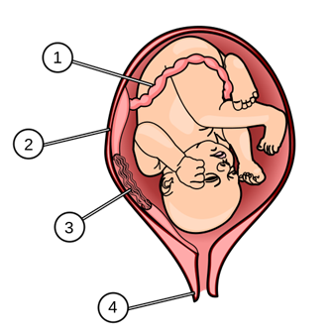

1. ________________________
2. ________________________
3. ________________________
4. ________________________

**b.** Describe two functions of structure number 3. (2 marks)

___________________________________________________________________

___________________________________________________________________

**c.** Before the child can be born, which structure in the above diagram has to change shape the most? (1 mark)

__________________________________________________________________

**7.** Using a flow diagram, describe the events that occur to enable milk to be released

from the nipples. (3 marks)

8. List three foetal diagnostic techniques and explain how these techniques are able to monitor the health of a developing embryo and/or foetus? (6 marks)

__________________________________________________________________

__________________________________________________________________

__________________________________________________________________

__________________________________________________________________

__________________________________________________________________

__________________________________________________________________

__________________________________________________________________

__________________________________________________________________

__________________________________________________________________

__________________________________________________________________

9. During pregnancy, the mother experiences many changes to her body that

increases her oxygen consumption. Describe **THREE (3)** significant physiological

changes in her body that cause an increase in oxygen consumption. (3 marks)

___________________________________________________________________

___________________________________________________________________

___________________________________________________________________

___________________________________________________________________

___________________________________________________________________

___________________________________________________________________

___________________________________________________________________

___________________________________________________________________

___________________________________________________________________

___________________________________________________________________

___________________________________________________________________

___________________________________________________________________

___________________________________________________________________

___________________________________________________________________

___________________________________________________________________

___________________________________________________________________

___________________________________________________________________

___________________________________________________________________

___________________________________________________________________

___________________________________________________________________

___________________________________________________________________

___________________________________________________________________

___________________________________________________________________

___________________________________________________________________

___________________________________________________________________

___________________________________________________________________

___________________________________________________________________

**END OF TEST**